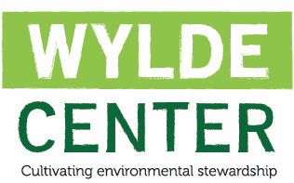
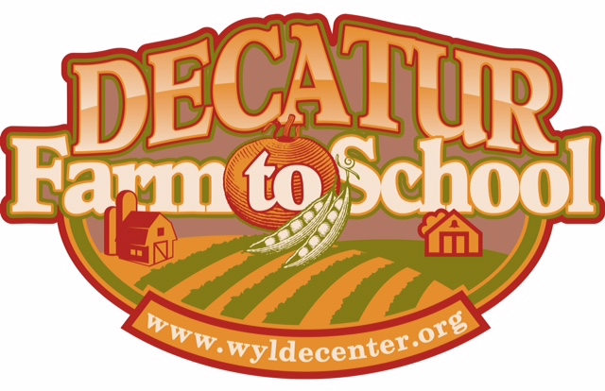

The Decatur Farm to School Executive Committee members would like to thank you for applying for a Decatur Farm to School Grant!

The Wylde Center’s Decatur Farm to School Grant Program was initiated to support the City Schools of Decatur (CSD) in their efforts to provide farm to school experiences to their faculty and students. Up to three $500 grants will be awarded to CSD per school year. Each school may only receive one grant per year. Funds may be used for garden support, field trips, teaching experiences, and/or materials, as related to farm to school education.

Who can apply?​ Teachers, Administrators, PTA members, or parent volunteers on behalf of their CSD School.

Your completed application must be received by Friday, September 7, 2018. Please complete the Grant Application below and email a PDF of the grant application to Becky Anne, member of the Decatur Farm to School Executive Committee, at rebecca.anne@me.com

The Decatur Farm to School Executive Committee expects to select three applicants. All applicants will be notified of the decision by September 14th, 2018.

Questions? Please contact Becky Anne at rebecca.anne@me.com.

Decatur Farm to School Grant Application

Your Name:
Your Email:
Your Phone Number:
School:

Position in School (Teacher, Administrator, PTA member, etc.):

Please type your responses and attach additional sheets as necessary.

● Statement of Interest​ (no more than 250 words): Why are you applying for a Decatur Farm to School Grant? What are your objectives and how do you plan to use this funding to enhance farm to school experiences in your school?

● Statement of Goals​ (no more than 250 words): What goals do you hope to achieve through participation in this program?

● Statement of Sustainability​ (no more than 250 words): How does your school envision sustaining the activities developed by this funding to continue beyond this funding period?

● If selected, the school is obligated to use the funds and complete the objectives by the 2018-2019 school calendar year. What funds are not used by the end of the school year will be returned back to DF2S.

● Decatur Farm to School requests that, upon completion of funded task(s), grantees provide a written summary, with photographs and additional documentation, as needed. Written summaries and/or any additional documentation, such as photos, may be included in a future DF2S school newsletter.

● If selected, to whom should Decatur Farm to School write the check and to whom should the check be mailed? Please provide name and address.

_______________________________________________

Applicant Signature and Date

_______________________________________________

School Administrator Signature and Date

